**Indian Institute of Technology Bombay**

**DEPARTMENT OF METALLURGICAL ENGINEERING & MATERIALS SCIENCE**

**MM 204 Transport Phenomena : 1019-20 : Spring**

**Tutorial 2 Jan 22, 2019, 0830h**

1. Grandmothers claim that during storms, water wells are easier to pump, but the water may be unfit to drink, because of an increase in suspended matter. This happens whether the storm brings rain or not? Is this true? If so, why would these wells respond to storms?
2. 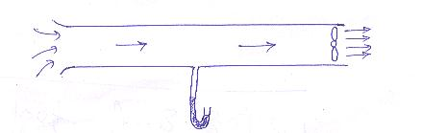A fan draws air at 30oC from a room at atmospheric pressure through a duct 20 m long and 0.4 m diam. and discharges it at atmospheric pressure outside. If a static pressure measurement in the central portion of the pipe shows a pressure of –10mm water gage, and the fan efficiency is 50%, calculate the wattage of the fan. Neglect friction. (We will consider this problem again with friction some time later).

1

3

**2**

1. 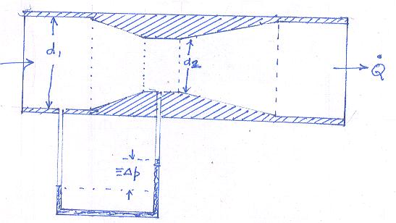(a) Water flows through a venturi (constriction) installed in a pipe as shown. Derive a relations ship between volumetric flow rate Q, Δp and dimensions d1 and d2. Neglect friction.

(b) In the above, the pressure difference between inlet at 1 and exit of the pipe at 3 should ideally be zero since the pipe is horizontal and the fluid is incompressible. However one measures a pressure drop of 30 mm water column. This is frictional loss, and gets converted to internal energy of water (increase in temperature). If the flow rate is 100 lpm and the density and the specific heat of water are 1000 kg/m3 and 4200 J/kg/K respectively, what is the increase in temperature of water from inlet to exit ?